

Semester One Examination, 2017

Question/Answer booklet

MATHEMATICS

SOLUTIONS
METHODS
UNIT 1

Section Two:

Calculator-assumed

Student Number: In figures

In words

Your name

Time allowed for this section
Reading time before commencing work: ten minutes
Working time: one hundred minutes

Materials required/recommended for this section
To be provided by the supervisor
This Question/Answer booklet
Formula sheet (retained from Section One)

To be provided by the candidate
Standard items: pens (blue/black preferred), pencils (including coloured), sharpener, correction fluid/tape, eraser, ruler, highlighters

Special items: drawing instruments, templates, notes on two unfolded sheets of A4 paper, and up to three calculators approved for use in this examination

Important note to candidates
No other items may be taken into the examination room. It is your responsibility to ensure that you do not have any unauthorised material. If you have any unauthorised material with you, hand it to the supervisor before reading any further.

Structure of this paper

Section | Number of questions available | Number of questions to be answered | Working  time (minutes) | Marks available | Percentage of examination
Section One:  Calculator-free | 7 | 7 | 50 | 52 | 35
Section Two:  Calculator-assumed | 13 | 13 | 100 | 98 | 65
 |  |  |  | Total | 100

Instructions to candidates

1. The rules for the conduct of examinations are detailed in the school handbook. Sitting this examination implies that you agree to abide by these rules.

2. Write your answers in this Question/Answer booklet.

3. You must be careful to confine your response to the specific question asked and to follow any instructions that are specified to a particular question.

4. Additional working space pages at the end of this Question/Answer booklet are for planning or continuing an answer. If you use these pages, indicate at the original answer, the page number it is planned/continued on and write the question number being planned/continued on the additional working space page.

5. Show all your working clearly. Your working should be in sufficient detail to allow your answers to be checked readily and for marks to be awarded for reasoning. Incorrect answers given without supporting reasoning cannot be allocated any marks. For any question or part question worth more than two marks, valid working or justification is required to receive full marks. If you repeat any question, ensure that you cancel the answer you do not wish to have marked.

6. It is recommended that you do not use pencil, except in diagrams.

7. The Formula sheet is not to be handed in with your Question/Answer booklet.

Section Two: Calculator-assumed 65% (98 Marks)
This section has thirteen (13) questions. Answer all questions. Write your answers in the spaces provided.

Working time: 100 minutes.

Question 8 (6 marks)
(a) The variables $C$ and $n$ are directly proportional to each other, so that when $n=10$, it is known that $C=25$. Sketch a graph of the relationship between $C$ and $n$ on the axes below. (3 marks)

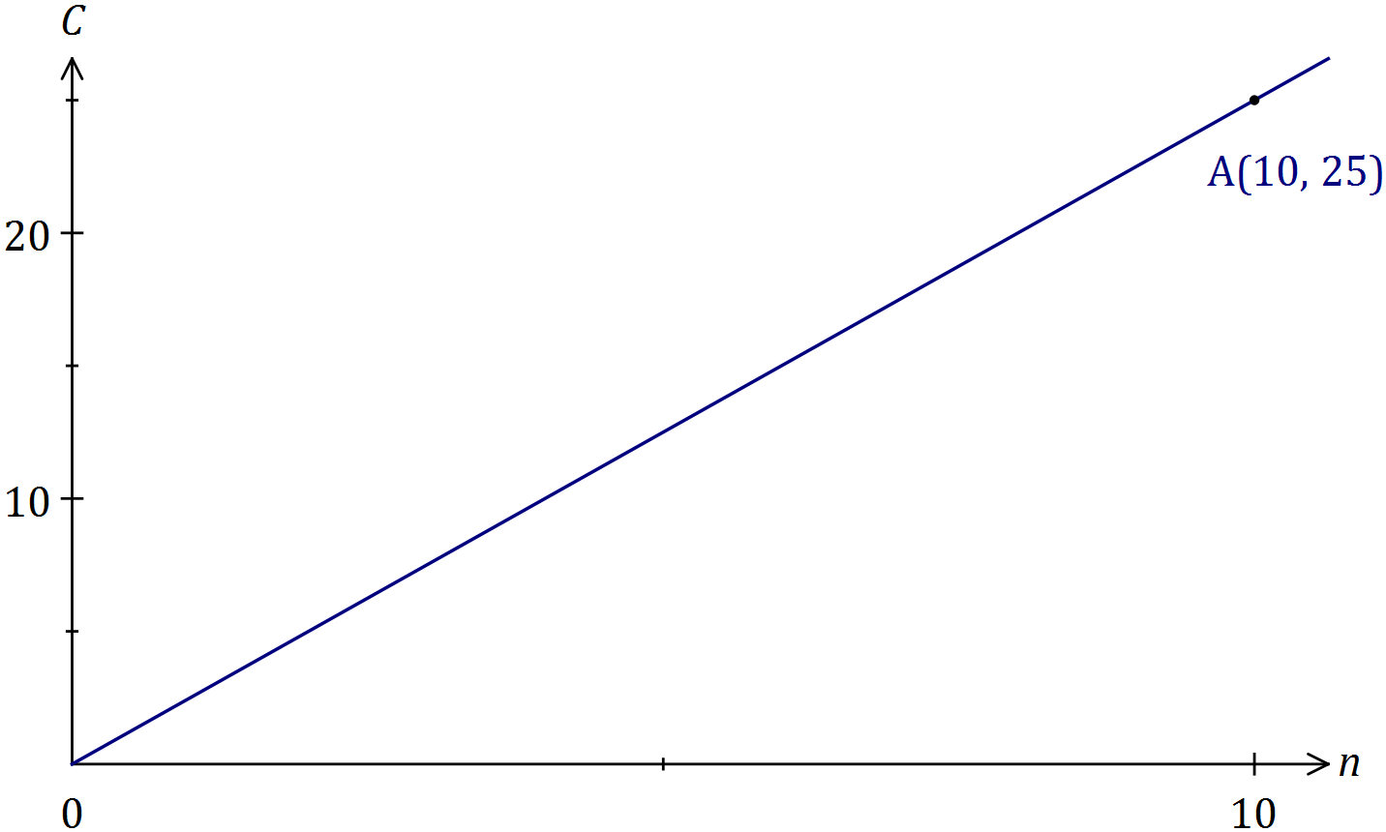
Solution
See graph
Specific behaviours
scales added to both axes
straight line through origin using ruler
indicates passes through (10, 25)

(b) The variables $A$ and $n$ are inversely proportional to each other, so that when $n=10$, it is known that $A=60$.

(i) Write an equation that relates $A$ and $n$. (2 marks)
Solution
$$A∝\frac{1}{n}⇒A=\frac{k}{n}$$
$$k=10×60=600⇒A=\frac{600}{n}$$

Specific behaviours
correct form of equation
determines constant

(ii) Determine the value of $n$ when $A=15$. (1 mark)
Solution
$$n=\frac{600}{15}=40$$

Specific behaviours
states value

Question 9 (9 marks)
(a) Determine the size, to the nearest degree, of the largest angle in a triangle with sides of lengths 23 cm, 28 cm and 31 cm. (3 marks)
Solution
$$θ=\cos^{-1}\left(\frac{{23}^{2}+{28}^{2}-{31}^{2}}{2×23×28}\right) \\ θ≈74°$$

Specific behaviours
shows use of cosine rule
substitutes correctly
determines angle

(b) Determine the value of $y$ in the diagram below. (3 marks)

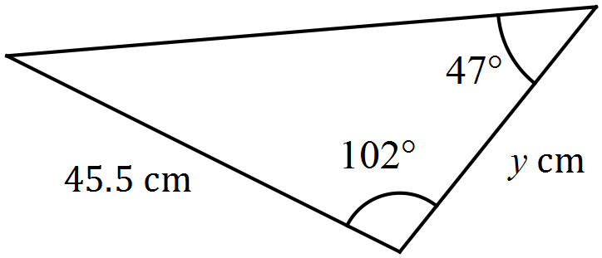
Solution
$$180-102-47=31°$$
$$\frac{y}{\sin{31}}=\frac{45.5}{\sin{47}}$$
$$y=32.04$$

Specific behaviours
determines angle
shows use of sin rule
determines value

(c) The area of the triangle shown below is 280 cm². Determine the value of $x$. (3 marks)

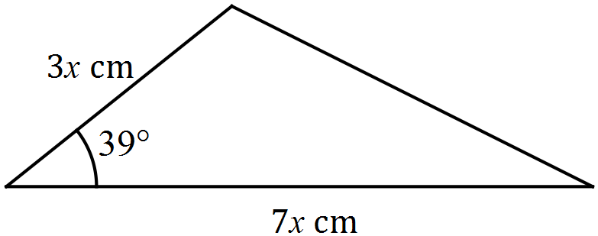
Solution
$$0.5×3x×7x×\sin{39}=280$$
$$x^{2}=42.37$$
$$x=6.51$$

Specific behaviours
uses area formula
substitutes correctly
solves for value

Question 10 (6 marks)
(a) State, with reasoning, which of the graphs shown below are not those of a function.
(3 marks)
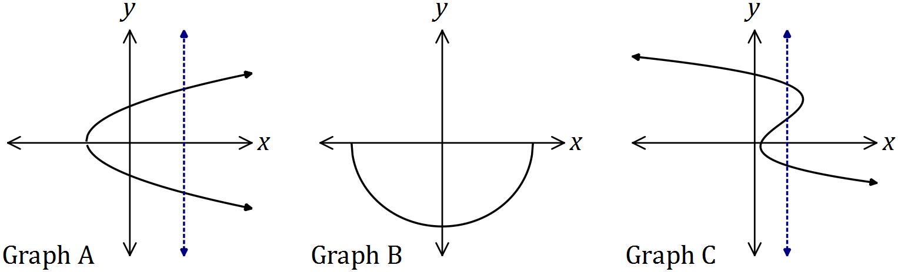
Solution
$A$ and $C$ are not graphs of functions, as a vertical line can be drawn to cut both in more than one place.

Specific behaviours
A
C
reasoning

(b) Draw the graph of the relation ${x^{2}+y}^{2}=2x-6y+26$. (3 marks)

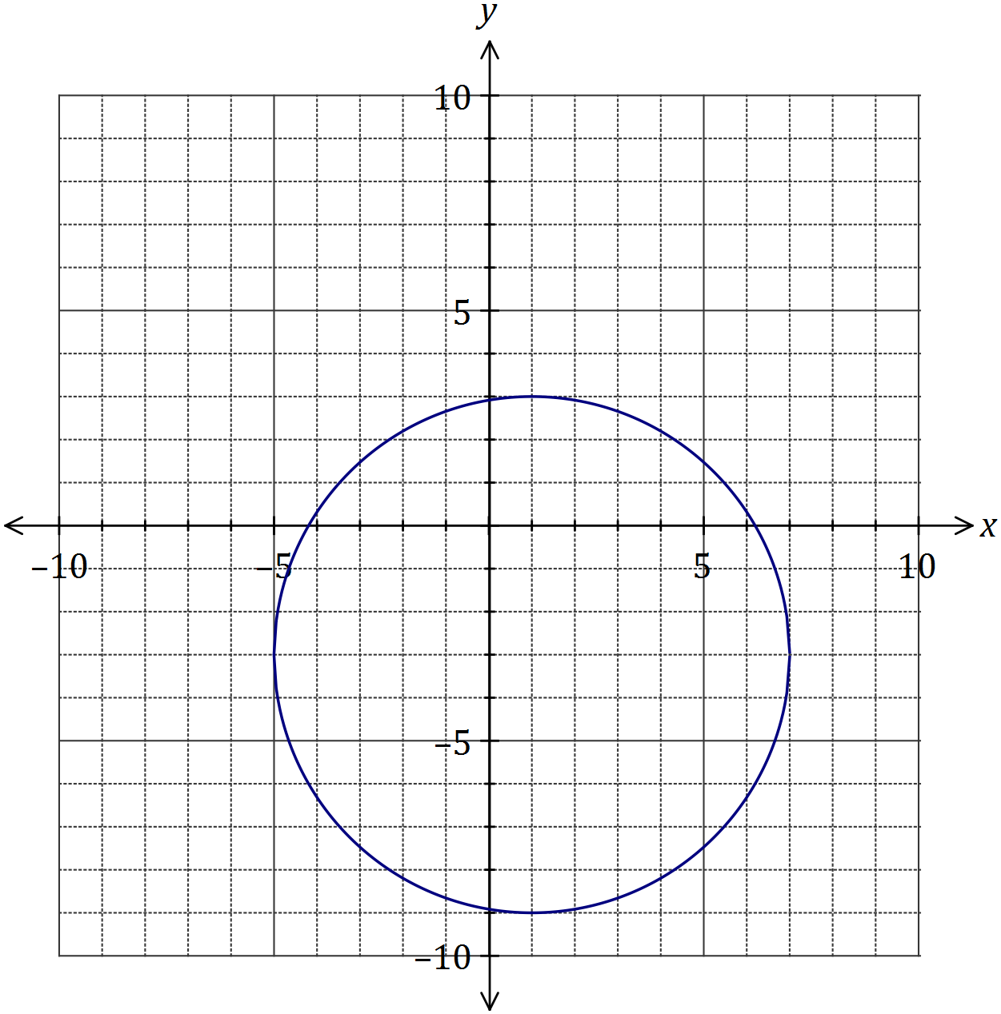
Solution
See graph
Specific behaviours
centred at (1, -3) and radius of 6
at least three axes-intercepts within $±0.5$
smooth circle

Question 11 (6 marks)
(a) The graphs of $y=a sin{(x)}, y=\sin{(bx)}, y=d\cos{(x)}$ and $y=\cos{(ex)}$ are shown below.

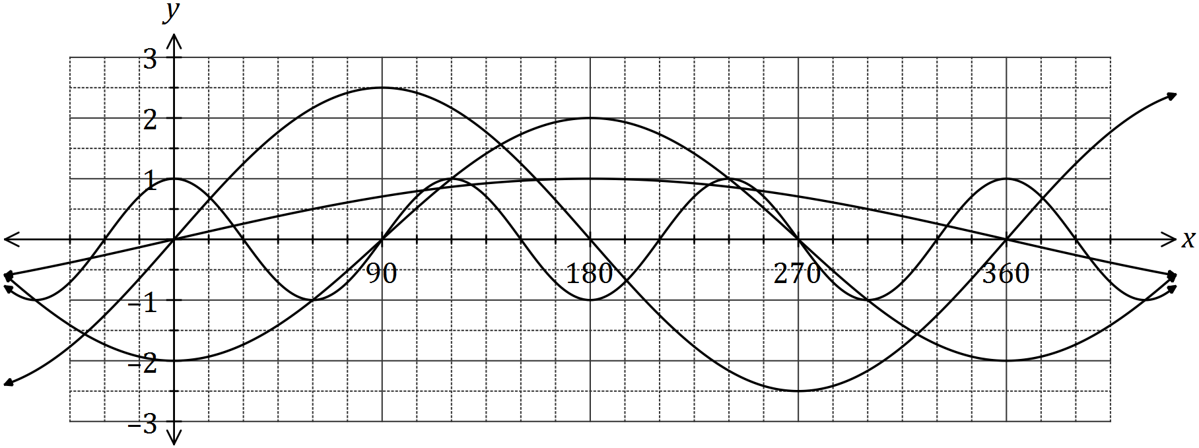

Determine the values of the constants $a, b, d$ and $e$. (4 marks)
Solution
$$a=2.5, b=0.5, d=-2, e=3$$

Specific behaviours
one mark per correct value

(b) The graph of $y=\cos{(x-α)}$ is drawn below.

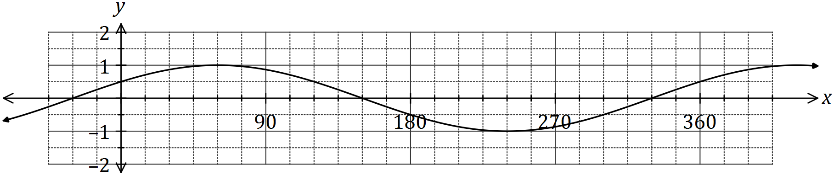

(i) State the value of the constant $α$, where $0°<α<360°$. (1 mark)
Solution
$$α=60°$$

Specific behaviours
states value

(ii) The graph is also that of $y=\sin{(x+β)}$. State the value of the constant $β$, where $0°<β<360°$. (1 mark)
Solution
$$β=30°$$

Specific behaviours
states value

Question 12 (8 marks)
(a) At 3 pm, the length of the shadow of a thin vertical pole standing on level ground is the same as the height of the pole. A while later, the angle of elevation of the sun has decreased by 12° and the length of the shadow has increased by 95 cm. Determine the height of the pole. (4 marks)

Solution
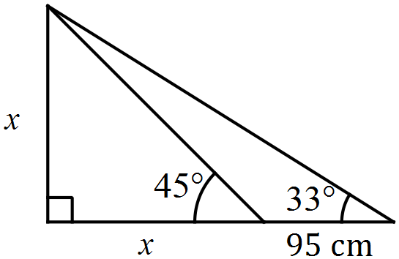

$$\tan\left(33\right)=\frac{x}{x+95}⇒x=176 \text{cm}$$

Specific behaviours
initial info sketch
extra info added to sketch
writes equation
solves equation with CAS

(b) A windscreen wiper on a car is 43 cm long and rotates through one-third of a circle, as shown below. The inner and outer radii of the arcs are 20 cm and 63 cm. Determine the shaded area, rounding your answer to a reasonable degree of accuracy. (4 marks)

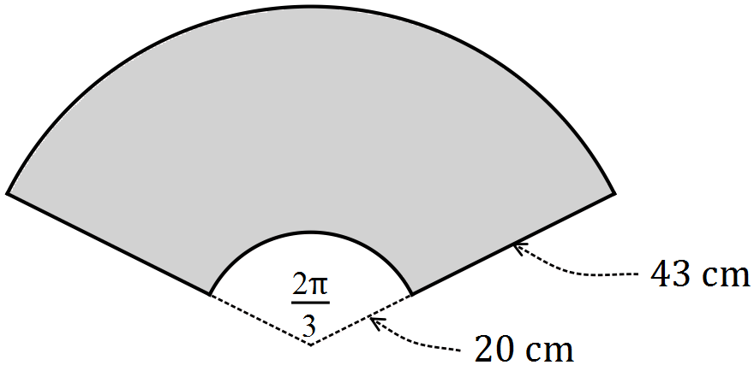

Solution
$${20}^{2}×\frac{2π}{3}=418.9$$
$${63}^{2}×\frac{2π}{3}=4156.3$$
$$\text{Diff}=3737.4$$
$$\text{Area}=3740 {\text{cm}}^{2}$$

Specific behaviours
inner sector
outer sector
works throughout to at least 4 sf
rounds answer to 2 or 3 sf

Question 13 (5 marks)
(a) Using the unit circle shown, determine the following in terms of $a$ and/or $b$, given that $θ$ is an acute angle measured in degrees.
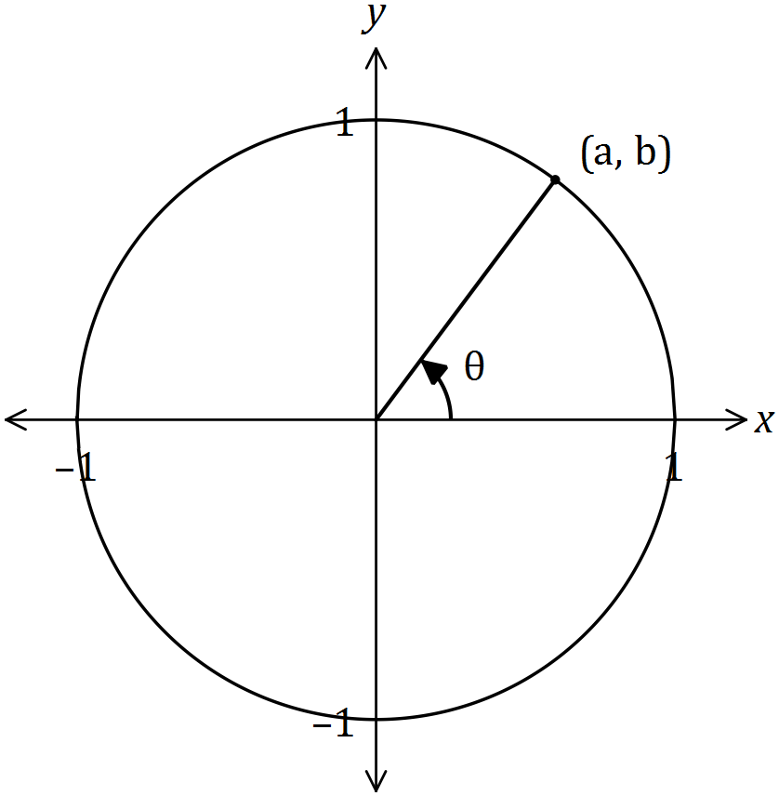

(i) $\sin\left(θ\right).$ (1 mark)
Solution
(i) $b$

(ii) $-a$

(iii) $-\frac{a}{b}$

Specific behaviours
(i)
(ii)
(iii)

(ii) $\cos{(180-θ)}$. (1 mark)

(iii) $\tan{(90+θ)}$. (1 mark)

(b) Determine $x$ in each of the following cases, where $0≤x≤\frac{π}{2}$.

(i) $\sin{x}=\sin{17π}$. (1 mark)
Solution
(i) $x=0$

(ii) $x=\frac{π}{6}$

Specific behaviours
(i)
(ii)

(ii) $\cos{x}=\cos{ }\frac{23π}{6}$. (1 mark)

Question 14 (8 marks)
(a) The graph of $y=2x^{2}+bx+16$ has a line of symmetry with equation $x=3$.

(i) Determine the value of $b$. (2 marks)
Solution
$$x=-\frac{b}{2a}⇒b=-3×2×2=-12$$

Specific behaviours
uses line of symmetry
value of $b$

(ii) Draw the graph of the parabola on the axes below. (3 marks)

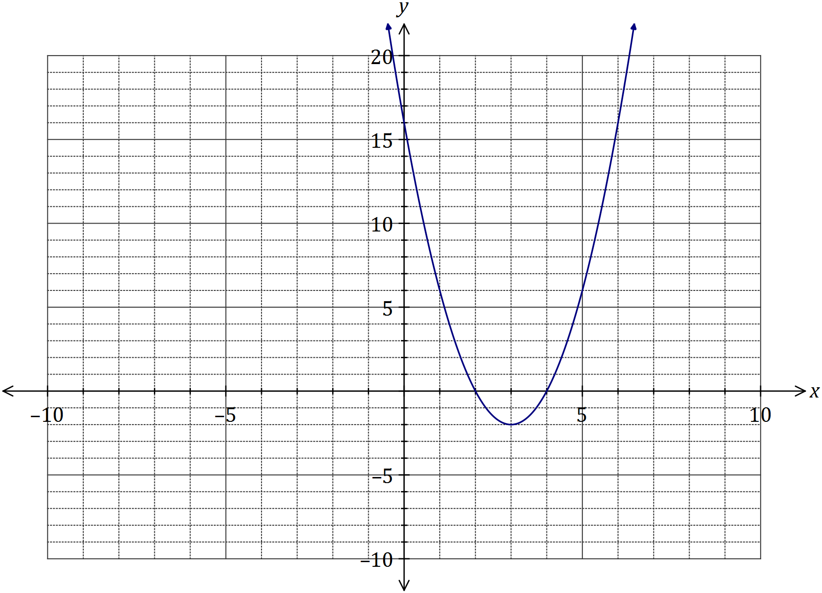
Solution
See graph
Specific behaviours
turning point
three axes intercepts
smooth curve

(b) One of the solutions to the equation $2x^{3}+21x^{2}+cx-495=0$ is $x=5$. Determine the value of $c$ and all other solutions. (3 marks)
Solution
Using CAS, when $x=5, 5c+280=0⇒c=-56$
Use CAS to solve $2x^{3}+21x^{2}-56x-495=0$
$$x=-11,x=-4.5 \text{and} x=5$$

Specific behaviours
substitutes $x=5$
determines $c$
states other two solutions

Question 15 (8 marks)
(a) On the axes below, draw the graph of $y=\tan\left(\frac{x}{3}\right)$ over the interval $0≤x≤5π$, clearly indicating the equations of any asymptotes. (3 marks)

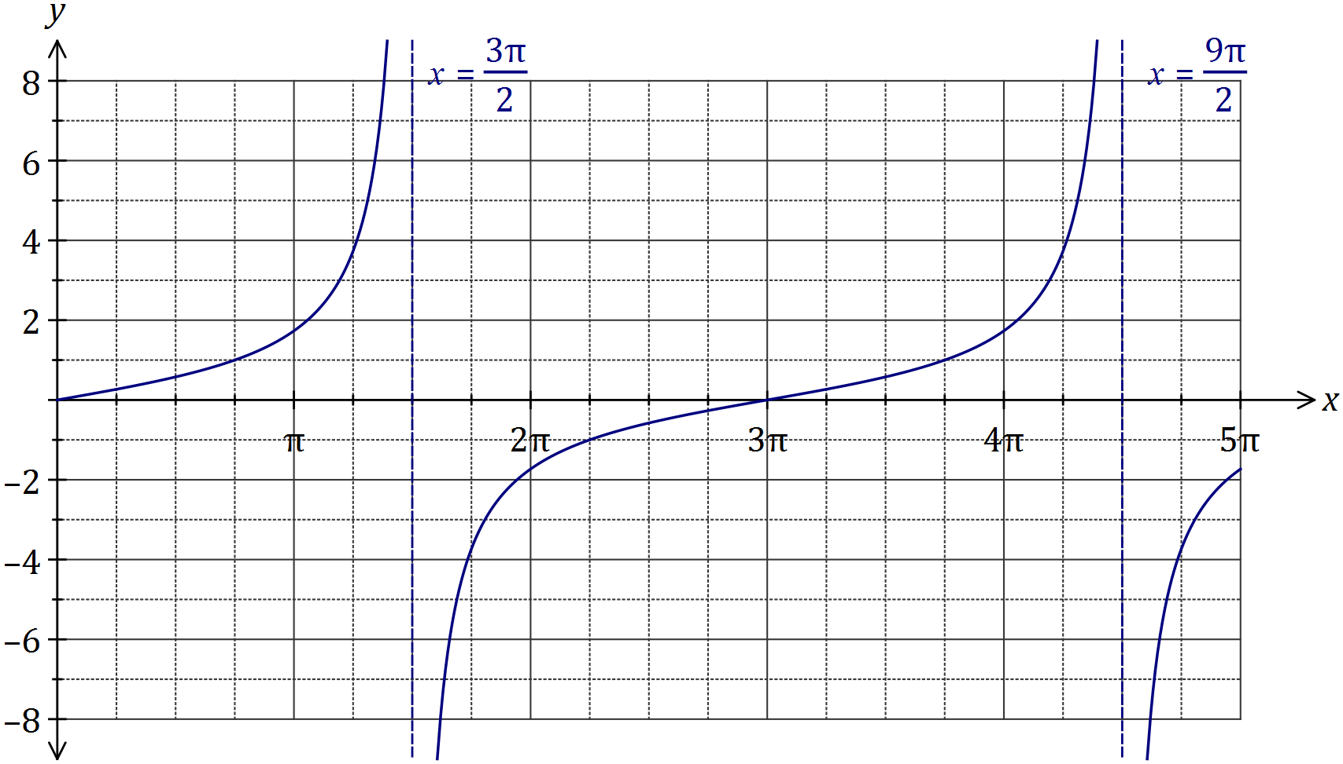
Solution
See graph
Specific behaviours
roots
general shape
equations of asymptotes

(b) Solve the following equations over the interval $0≤x≤5π$.

(i) $\tan\left(\frac{x}{3}\right)=-1$. (1 mark)
Solution
$$x=\frac{9π}{4}$$

Specific behaviours
one solution

(ii) $\tan\left(\frac{x}{3}\right)-\sqrt{3}=0$. (2 marks)
Solution
$$x=π, x=4π$$

Specific behaviours
first solution
second solution

(c) Determine the smallest positive value of $α$ so that $\tan\left(x-\frac{5π}{6}\right)=\tan\left(x+α\right)$. (2 marks)
Solution
Function has period of $π$ and so $α=π-\frac{5π}{6}=\frac{π}{6}$

Specific behaviours
uses period
determines $α$

Question 16 (8 marks)
The graph of the function is defined by $f\left(x\right)=$ $\frac{a}{x+b}$ is shown below.

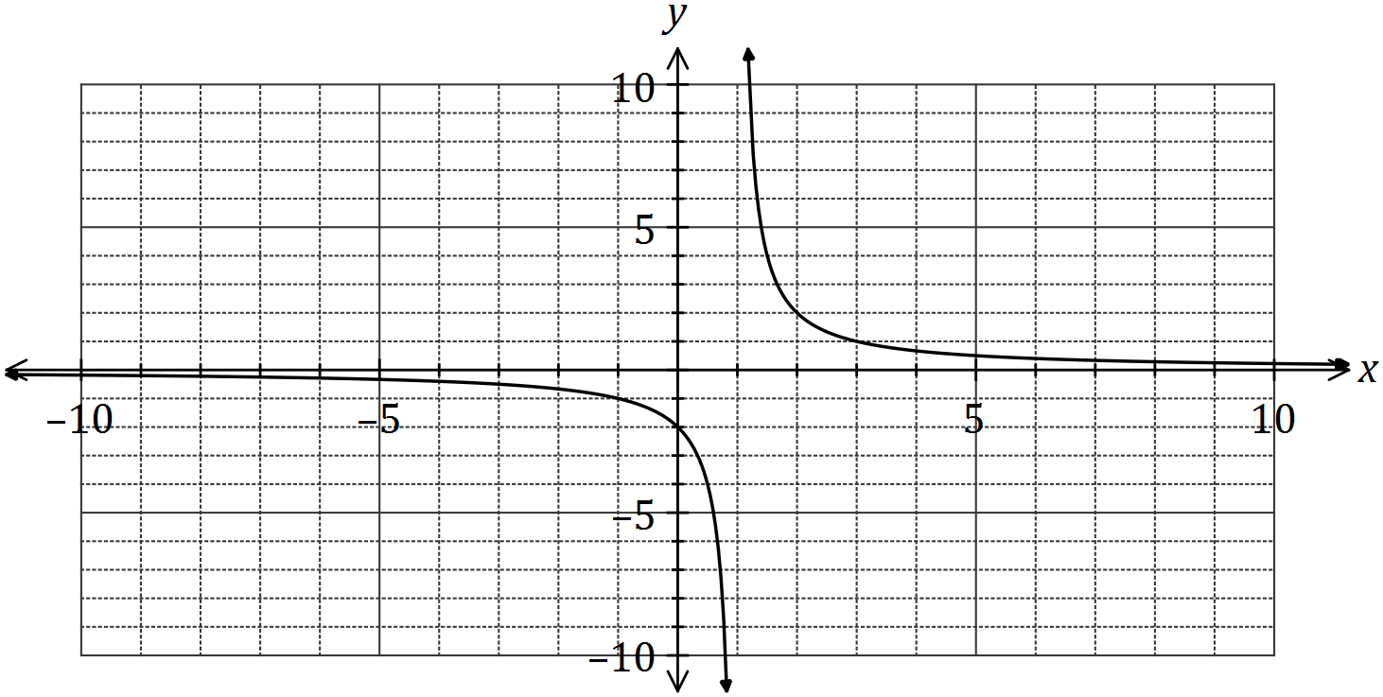

(a) Determine the values of $a$ and $b$. (2 marks)
Solution
Using vertical asymptote, $b=-1$
Using $y$-intercept, $a=2$

Specific behaviours
value of $a$, value of $b$

(b) State the domain and range of $f\left(x\right)$. (2 marks)
Solution
$$D_{f}=\left\{x:x∈R, x≠1\right\}$$
$$R_{f}=\{y:y∈R, y≠0\}$$

Specific behaviours
indicates $x≠1$, indicates $y≠0$

(c) Determine the equations of the asymptotes of the graph of $y=f(2x)$. (2 marks)
Solution
Vertical asymptote: $x=\frac{1}{2}$, horizontal asymptote: $y=0$

Specific behaviours
vertical asymptote, horizontal asymptote.

(d) Describe the transformation required on the graph of $y=f(x)$ to obtain the graph of

(i) $y=f(x+8)$. (1 mark)
Solution
Translate 8 units to the left.

Specific behaviours
description

(ii) $y=\frac{1}{2}f(x)$. (1 mark)
Solution
Dilate vertically by scale factor $\frac{1}{2}$

Specific behaviours
description

Question 17 (9 marks)
A straight line with equation $y=mx+n$, a parabola with equation $y=px^{2}+qx+r$ and a cubic with equation $y=h(x)$ all pass through the points $E(1, -4)$ and $F(2, 0)$.

(a) Determine the values of the constants $m$ and $n$ in the equation of the straight line.
(2 marks)

Solution
$$m=\frac{0--4}{2-1}=4$$

$$y-0=4\left(x-2\right)⇒y=4x-8⇒n=-8$$

$$m=4, n=-8$$

Specific behaviours
determines gradient
determines $y$-intercept

(b) Determine the values of the constants $p$, $q$ and $r$ in the equation of the parabola, given that $E$ is a minimum turning point of the parabola. (3 marks)
Solution
$$y=p{\left(x-1\right)}^{2}-4$$

$$0=p{\left(2-1\right)}^{2}-4$$
$$p=4$$

$$y=4{\left(x-1\right)}^{2}-4=4x^{2}-8x \text{(CAS)}$$
$$p=4, q=-8, r=0$$

Specific behaviours
uses $p$, turning point form and point $E$
determines $p$
expands and states other values

(c) Draw the graph of the cubic on the axes below, given that $E$ is a point of inflection and $F$ is a maximum turning point of the cubic. (4 marks)

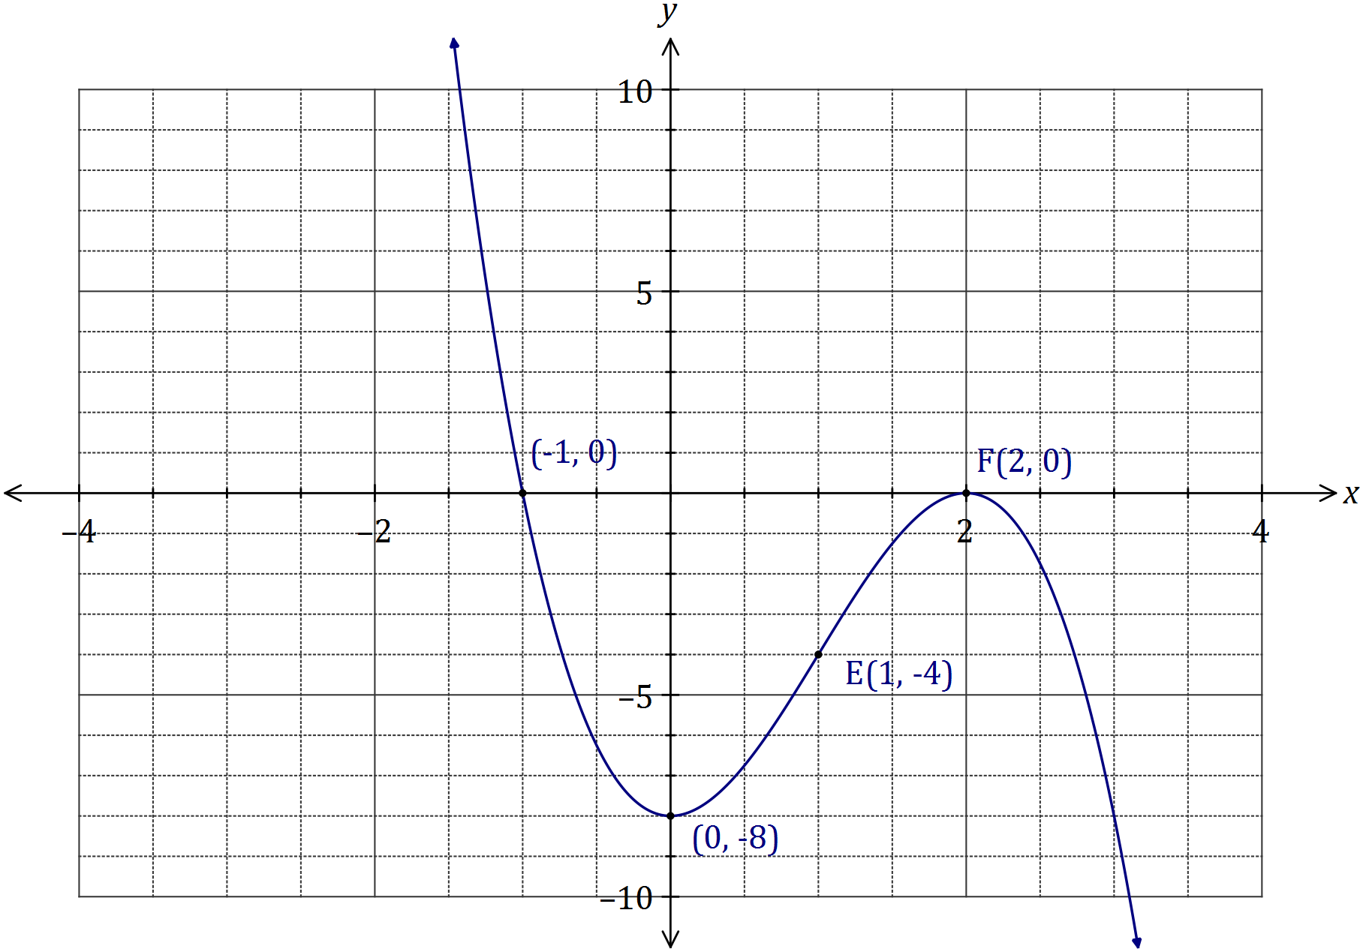
Solution
See graph
Specific behaviours
point of inflection at $E$
maximum at $F$
Uses rotational symmetry about point of inflection to obtain
minimum close to $(0, -8)$
root close to $(-1, 0)$

Question 18 (8 marks)
Over a 24-hour period, the depth of water, $d$ metres, in a harbour at time $t$ hours after midnight was given by
$$d=7.5\sin\left(\frac{πt}{6}\right)+9, 0≤t≤24.$$

(a) Determine the depth of water at 11 pm. (1 mark)
Solution
$$d=5.25 \text{m}$$

Specific behaviours
states depth

(b) Draw the graph of the water depth on the axes below. (3 marks)
Solution
See graph
Specific behaviours
location of start and maximums
location of end and minimums
smooth connecting curve

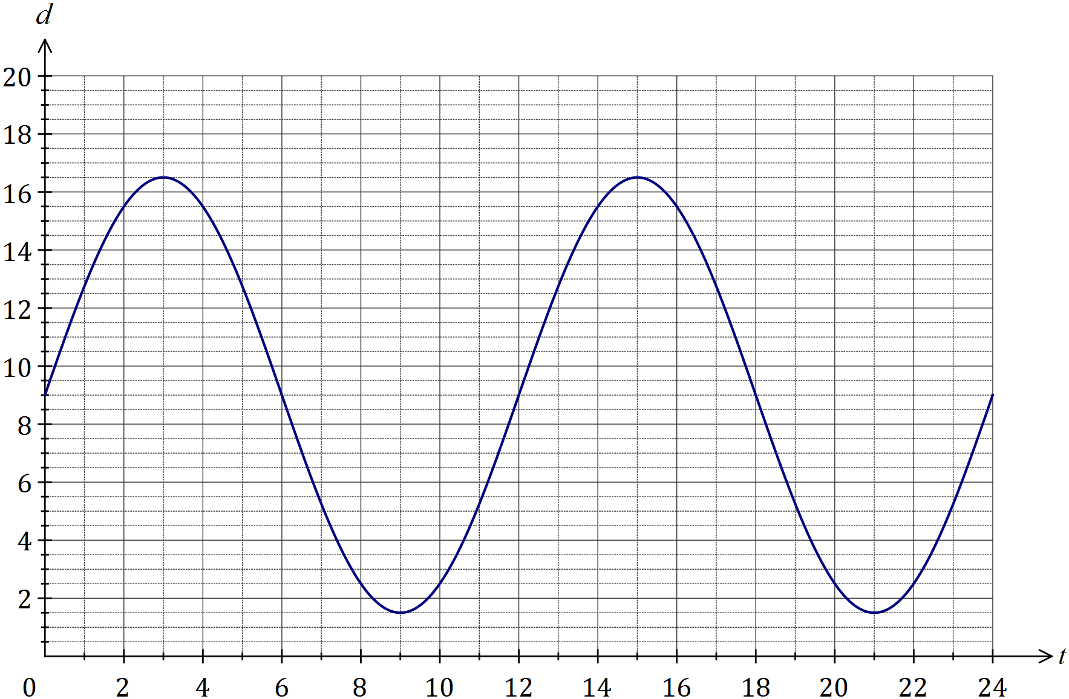

(c) At what time, in hours and minutes, did the depth of water first exceed 15 metres?
(2 marks)
Solution
$t=1.771$ - at 1:46 am

Specific behaviours
time as decimal
time in h and m

(d) Determine the fraction of the 24-hour period during which the depth of water exceeded 12.75 m. (2 marks)
Solution
Between 1 am and 5 am in first 12 h.
$$\frac{4}{12}=\frac{1}{3}$$

Specific behaviours
determines time interval
states fraction

Question 19 (8 marks)
The graph of $y=f(x)$ is drawn below over its natural domain, where $f(x)=x^{n}$.

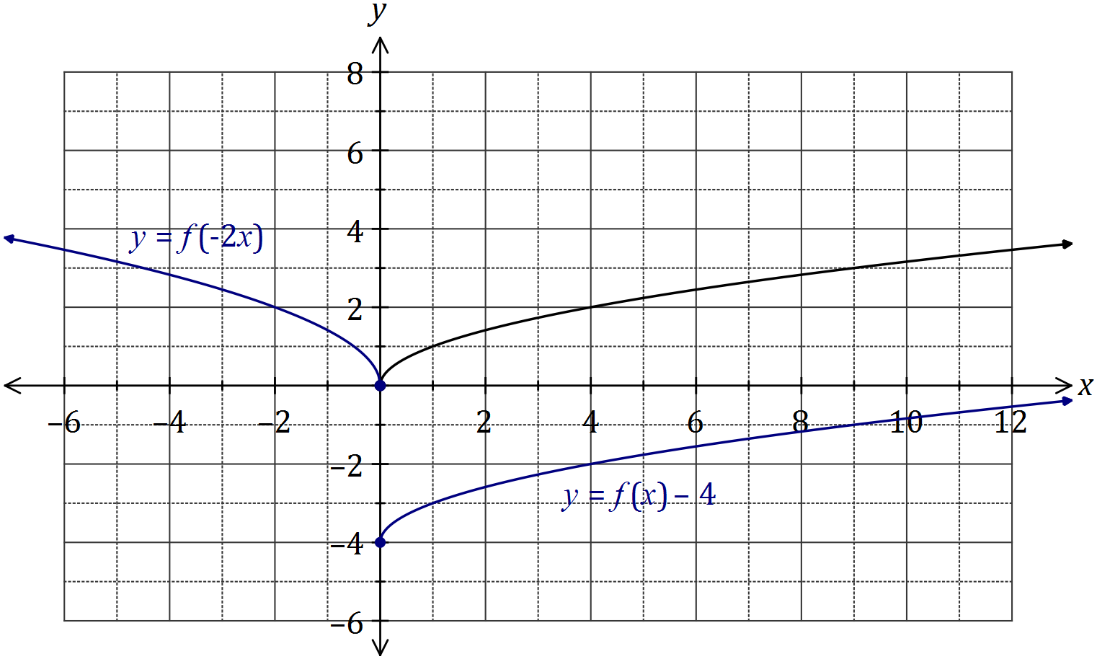

(a) The value of $n$ is either $-2, -1, -\frac{1}{2}, \frac{1}{2}, 1$ or $2$. State the correct value of $n$ and justify your choice. (2 marks)
Solution
$n=\frac{1}{2}$.
By substitution of $x=4$, only $4^{\frac{1}{2}}$ gives a $y$-coordinate of $2$.

Specific behaviours
value
suitable justification

(b) Explain why the domain of the function $f$ is $\{x:x∈R, x≥0\}$. (2 marks)
Solution
$x^{\frac{1}{2}}=\sqrt{x}$. Hence the domain of $f$ is the set of non-negative real number, as it is not possible to determine the square root of negative real numbers.
Specific behaviours
all non-negative real numbers
explains square root issue

(c) On the axes above, sketch and label the graphs of
Solution
See graph
Specific behaviours
starts at $(0, -4)$
smooth curve only in 4th quadrant

(i) $y=f\left(x\right)-4$. (2 marks)

(ii) $y=f(-2x)$. (2 marks)
Solution
See graph
Specific behaviours
reflected in y-axis
dilated, passes close to $(-2, 2)$

Question 20 (9 marks)
(a) A running track has circular ends of radius 100 m and two straight, parallel sides $PQ$ and $RS$ that are both 120 m long, as shown below. Determine, to the nearest metre, the total length of the track. (4 marks)

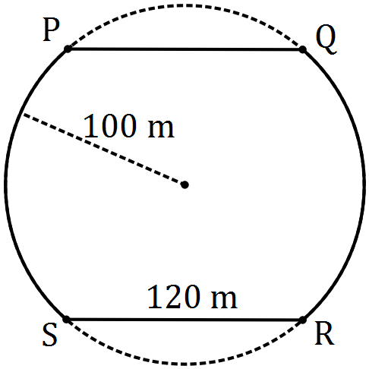
Solution
$$∠POS=2×\cos^{-1}{\frac{60}{100}} \\ ∠POS=2×0.9273=1.8546 \\ \text{arc} PS=100×1.8546=185.46 \\ \text{Total} 2×\left(185.46+120\right)=610.92≈611 \text{m}$$

Specific behaviours
method to find arc angle
determines arc angle
arc length
total length

(b) The diagram shows a circle with centre $O$ and diameter $BC$, and an equilateral triangle $ABC$. Determine the exact fraction of the area of the circle that lies outside the triangle.
(5 marks)
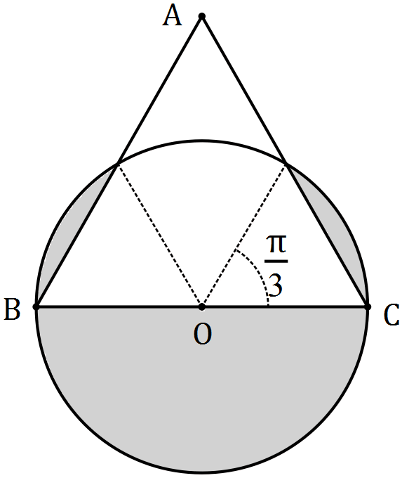
Solution
$$\text{Segment angle}=\frac{π}{3} \\ \text{Area segments}=2×\frac{1}{2}r^{2}\left(\frac{π}{3}-\sin{\frac{π}{3}}\right) \\ =r^{2}\left(\frac{π}{3}-\frac{\sqrt{3}}{2}\right) \\ \text{Outside area}=\frac{πr^{2}}{2}+r^{2}\left(\frac{π}{3}-\frac{\sqrt{3}}{2}\right) \\ \text{Fraction}=\frac{\frac{πr^{2}}{2}+r^{2}\left(\frac{π}{3}-\frac{\sqrt{3}}{2}\right)}{πr^{2}} \\ =\frac{5}{6}-\frac{\sqrt{3}}{2π}=\frac{5π-3\sqrt{3}}{6π}$$

Specific behaviours
determines segment angle
determines segment area
determines total outside area
expresses outside as fraction of whole
simplifies (CAS) as exact value

Additional working space

Question number: _________

© 2016 WA Exam Papers. Kennedy Baptist College has a non-exclusive licence to copy and communicate this paper for non-commercial, educational use within the school. No other copying, communication or use is permitted without the express written permission of WA Exam Papers. SN245-092-8.

